### NETWORK CONFIGURATION

Updated: 12/01/2023

Description

This work shall consist of installing, configuring, and provisioning a fully operational Ethernet Local Area Network (LAN), which provides communication with remote traffic control field devices from the Kane County Division of Transportation (KCDOT) Arterial Operations Center (AOC). If plans specify the expansion of an existing network or interconnect, this work shall consist of coordination with KCDOT in the understanding of the existing network configurations and appropriately expanding upon and applying those configurations to new devices being brought onto the network.

Devices include traffic signal controllers, loop detectors, Malfunction Management Units (MMU), Uninterruptable Power Supply (UPS) units, video detection systems, Microwave/Radar detection systems, and CCTV (PTZ) cameras, or other specified Intelligent Transportation System (ITS) field device as shown on the plans or as have Ethernet connectivity options. These ITS devices may include, but are not limited to, Dynamic Message Signs (DMS), Radar Speed Signs (RSS), Flashing Beacon Controllers, and Roadway Weather Instrumentation Systems (RWIS) if present in contract.

Should the contract or plans include ITS field devices such as but not limited to controllers, PTZ cameras, video detection cameras, RWIS, or DMS this NETWORK CONFIGURATION work shall also include any necessary integration of those items into KCDOT’s Advanced Traffic Management System (ATMS), TransSuite and Video Wall management system, Christie Phoenix.

Construction

Contractor shall include configuring Ethernet switches and any other device with network connectivity, assigning IP addresses to field devices based on KCDOT Traffic staff input/standards, troubleshooting and submitting documentation to KCDOT Traffic staff of final configurations and the verified testing of communication to each device from the network. Configuring switches with dedicated Virtual Local Area Network (VLAN) and port assignments to match existing network switch settings.

This work shall also require coordination with each manufacturer of field end devices, and networking equipment to ensure successful communications between the network and field devices.

Contractor shall provide a list of any camera video feed URLs that are being brought online as part of this contract. In the case of Video Detection camera feeds, each camera shall have a separate video streaming channel with a respective video feed URL such that all camera feeds (Processed feeds showing detection overlay) can be streamed simultaneously. If additional equipment/wiring/configurations are necessary to provide this functionality to video detection cameras it shall be included in this pay item.

The contractor shall also coordinate final connection to the existing system network with the KCDOT network consultant of record. The contractor shall setup a meeting (and continue coordination as needed) between the contractor, KCDOT IT staff, KCDOT stakeholders, and the Engineer to coordinate programming requirements for the final network programming prior to final turnover. **A final engineering drawing(s) shall be produced by the contractor** which inventories all fiber optic cable/tube/fiber terminations and splicing and which inventories all IP configurations for each device which has been brought online into the KCDOT interconnect.

EXAMPLE ENGINEERING DRAWING  
(to document Cable/Tube/Fiber terminations and splices, IP addresses and port assignments)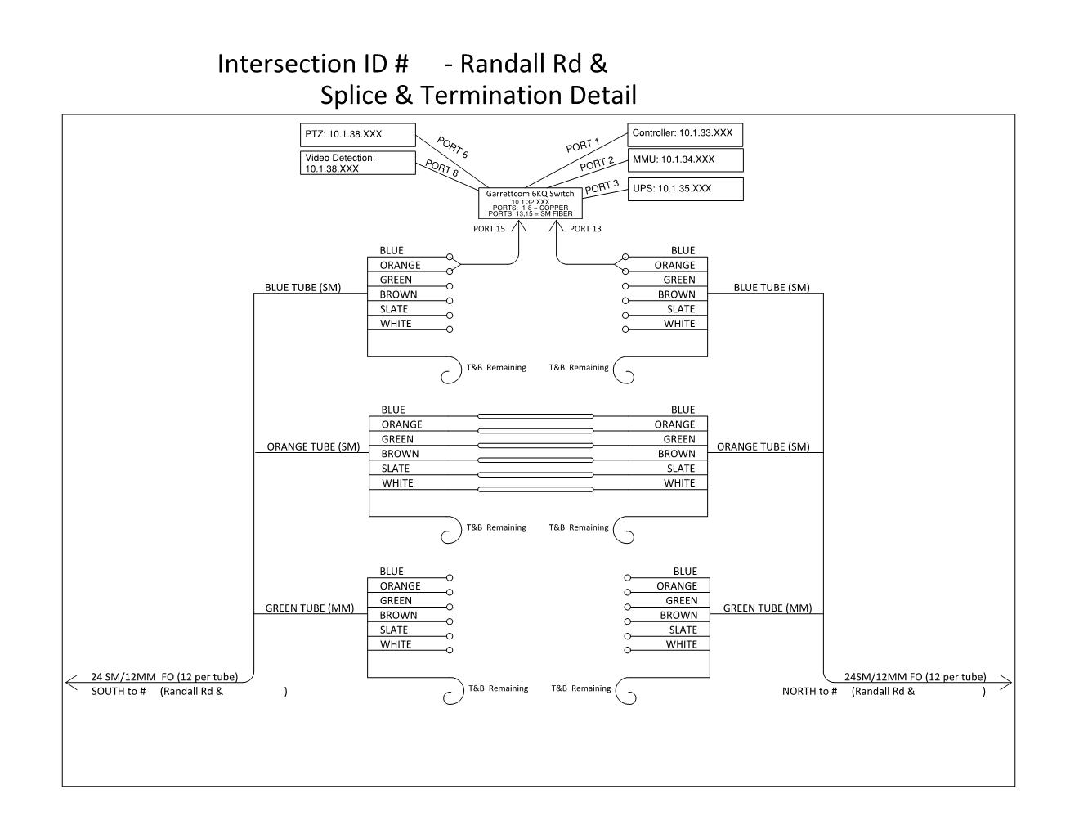

Testing and Integration

Any incompatibility with the system or network shall remain the responsibility of the contractor to provide an alternate solution for which shall also meet the satisfaction of KCDOT and other KCDOT network users. The below scope of work may be required to be completed by the contractor upon request of KCDOT.

1. TransCore’s TransSuite ATMS Integration
   1. Add and configure any controllers, controller databases, and system detectors.
   2. Add and configure any PTZ cameras or other video feeds. Pan, Tilt, and Zoom functionality should work within TransSuite.
   3. Add or configure a new Intersection Diagram within TransSuite ATMS Explorer.
   4. Add, configure, or modify the appropriate TransSuite Time Space diagram if new controllers are added into the network within 1 mile spacing of an existing system.
   5. TransCore Contact information: 770-246-6202 or [ITS@Transcore.com](mailto:ITS@Transcore.com)
2. Christie Digital’s Phoenix system (Videowall) Integration
   1. Add new camera feed inputs for each video feed URL added to the network.
   2. Christie Digital Contact information: 714-236-8610

Basis of Payment

The work shall be paid for at the contract unit price per lump sum for NETWORK CONFIGURATION, which price shall be payment in full for all communication network configurations, coordination, and integration necessary to deliver an Ethernet network that provides successful communications between all field devices and the communication backhaul to the KCDOT Traffic Office and ATMS.